Loadbalancer

1.it will distributed the traffic to all the registered instances.

2.across the availability zones with in the region which are healthy.

3.it is distributed in round robin mechanism.

4. we have 4 types of load balancers.

a. classic load balancer

b. application load balancer

c. network load balancer

d .gateway loadbalancer

5. we need two subnets to create a load balancer.

Application load balancer

Choose an Application Load Balancer when you need a flexible feature set for your applications with HTTP and HTTPS traffic. Operating at the request level, Application Load Balancers provide advanced routing and visibility features targeted at application architectures, including microservices and containers.

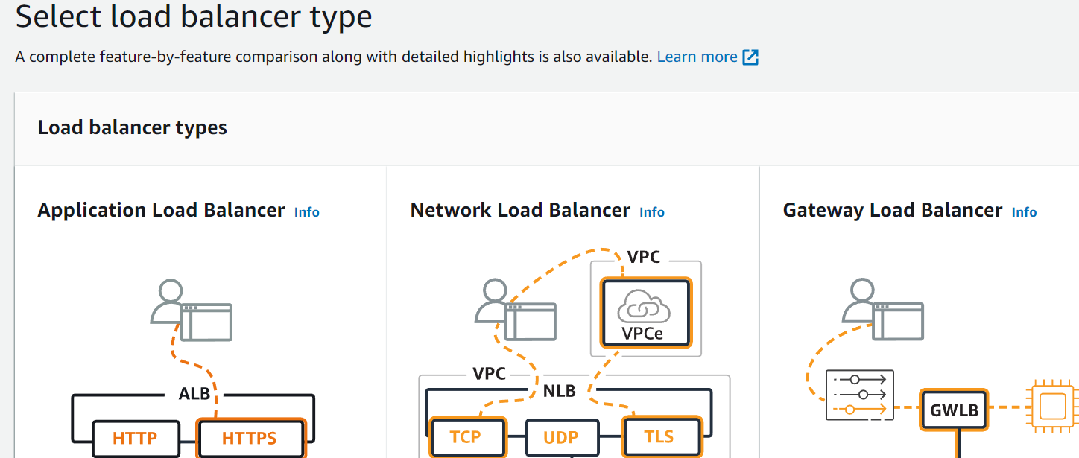

We have to provide name to the load balancer.

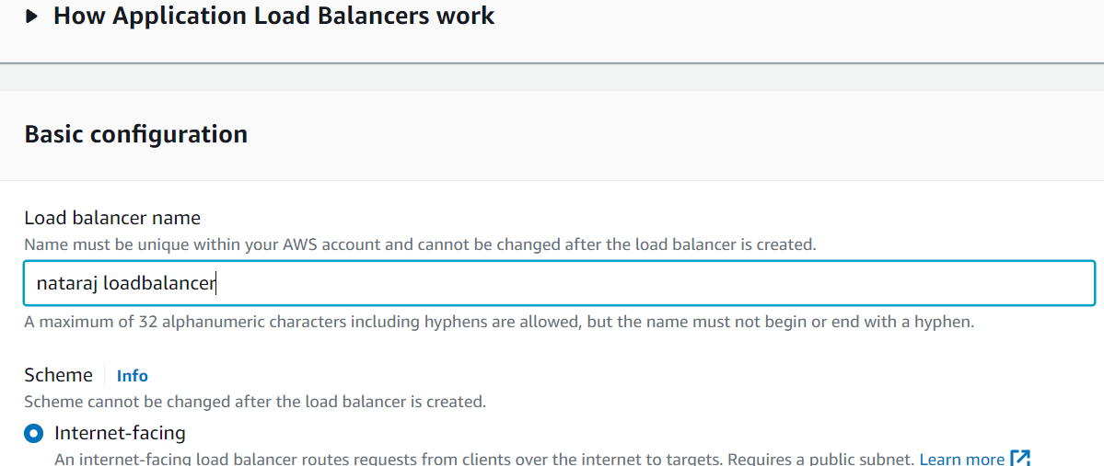

We need to select vpc and subnets in below avalibity zones.

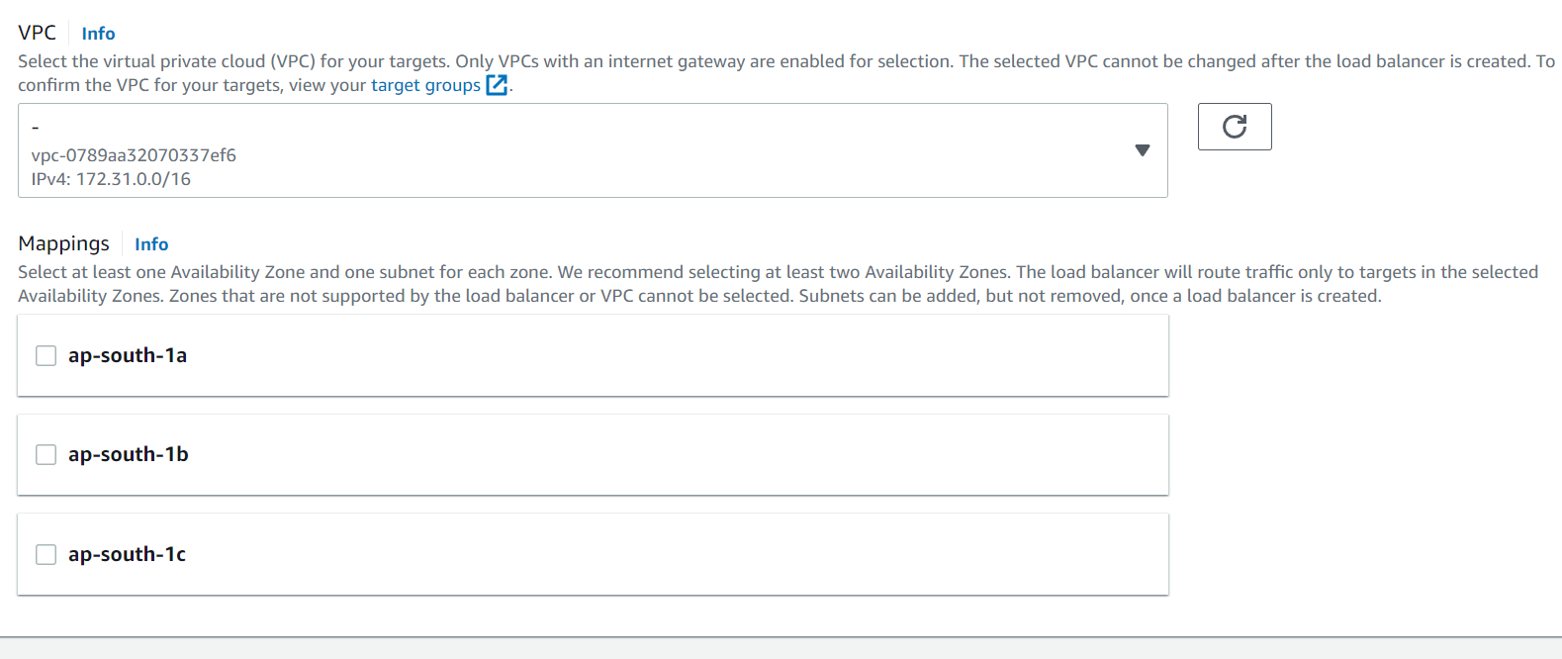

Create target groups for ELB

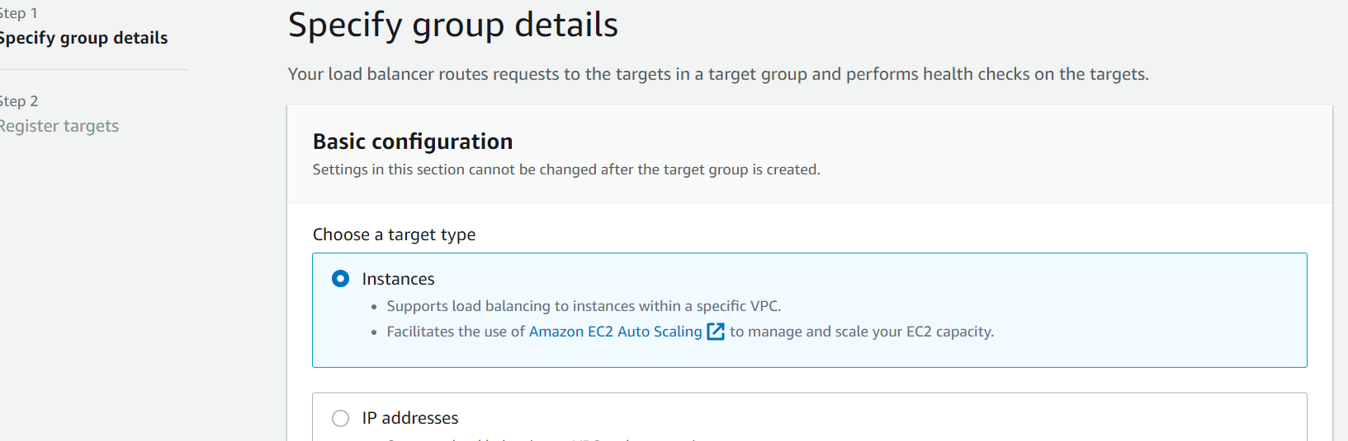

After creating target groups we need to add instances in target groups.

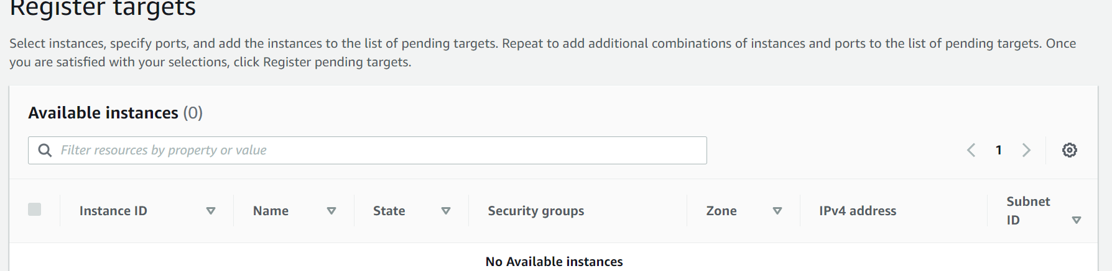

Load balancer has been created successfully.

